Mary Claire Lanser
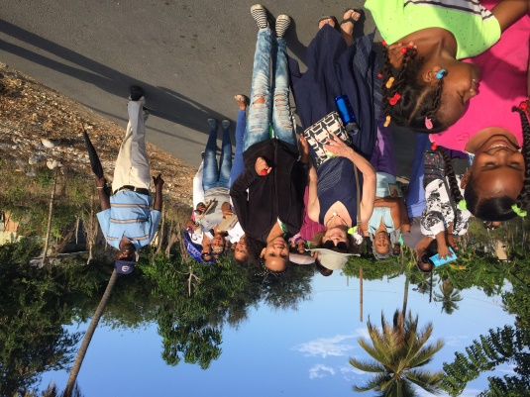
My La Sagrada Familia experience will stay with me the rest of my life. Beautiful, loving people quickly became my friends. Projects that are in process (things we take for granted) such as clean water, early childhood education, safe homes, latrines, and occupational training are deeply appreciated. My sister, Victoria, and I concentrated on the sewing center, where women learn to sew items for their homes and for sale. Many of the women are already excellent seamstresses and tailors, and some are beginners. Even more important, they are learning the power of entrepreneurship in a culture where women are not considered equal to men. With the generous help of friends and businesses, I continue to send fabric and sewing notions. I hope to have items for sale in the Cathedral of St. John the Evangelist narthex.
While there are many activities to complete, this was a Lenten Retreat, where I got much more spiritually than I bargained for. Even though I didn’t understand some parts of daily Mass celebrated in Spanish by Father Juan Manuel, I got goosebumps just being among the devout members of the parish. Many of them attend every single day. My very best memory is of the Stations of the Cross celebrated in a neighborhood where each station was in front of someone’s house, with little hand crafted shrines. To see such excitement about faith among all ages walking the route and praying together opened my own heart. A teenager named Cecilia took my hand and walked with me the entire time. (Seriously, do you know a teenage girl who would do that here?) I guess I thought we were going to give something to the people of our sister parish. I am pretty sure everyone who went on this Retreat will say that we are the fortunate ones. The next Lenten Retreat to La Sagrada Familia will be March 12 – 19 of 2019. Anyone interested should put it on their calendars.
- Mary Claire Lanser

