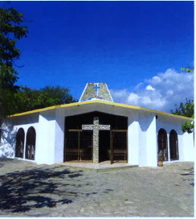
Christmas Greeting
from
La Sagrada Familia

Dear Cathedral Parishioners,

We want to wish all our brothers and sisters from Saint John Cathedral a Blessed Christmas. The festivities surrounding the celebration of the Nativity of the Lord are always an opportunity to be grateful to our God for his immense love for us. If we take a look of the past year each one of us has a lot of things to be grateful for in this Christmas. In La Sagrada Familia, we are grateful for this partnership of love between our two communities. Language is a barrier, we know; but we also know that God’s Love unites us in a very unique way as part of the Body of Christ. We count on your prayers as we also pray for all of you in this Holy Season. Secondly, we are grateful because this year, after 37 years of twinning relationship with Milwaukee, we got our first permanent deacon, Domingo Perdomo, from Proyecto 4 (the first community to which priests from Milwaukee arrived in 1981). For your love and the blessing of having a permanent deacon in our midst we are grateful to God.

Merry Christmas to you.

Fr. Juan
Pastor of La Sagrada Familia

